**Department of Electrical Engineering**

|  |  |
| --- | --- |
| **Faculty Member:____________________** | **Dated: ____________________** |
|  |  |
| **Course/Section:____________________** | **Semester: __________________** |
|  |  |

**Computer Organization and**

**Achitecture (EE321)**

**Lab # Benchmarking System performance**

|  |  |  |
| --- | --- | --- |
| **Name** | **Reg. no.** | **Total/15** |
| **Arifullah Jan** | **186943** |  |
| **Bilal Khalid** | **128608** |  |
| **Waqas Yaseen** | **196819** |  |
|  |  |  |

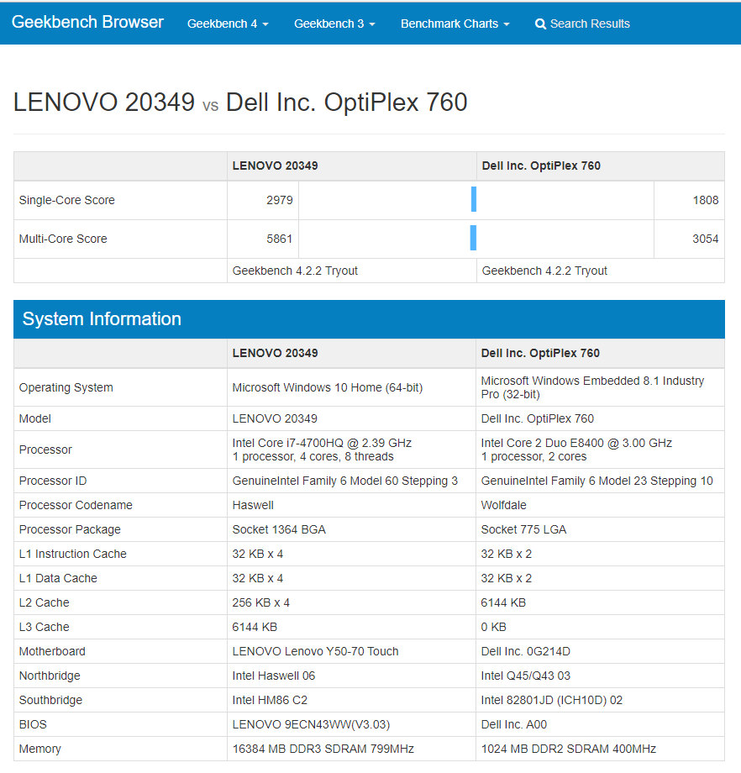

|  |  |  |
| --- | --- | --- |
|  | Lenovo y50 | LAB PC |
| L1 Instruction Cache | 32 KB x 4 | 32 KB x 2 |
| L1 Data Cache | 32 KB x 4 | 32 KB x 2 |
| L2 Cache | 256 KB x 4 | 6144 KB |
| L3 Cache | 6144 KB | 0 KB |

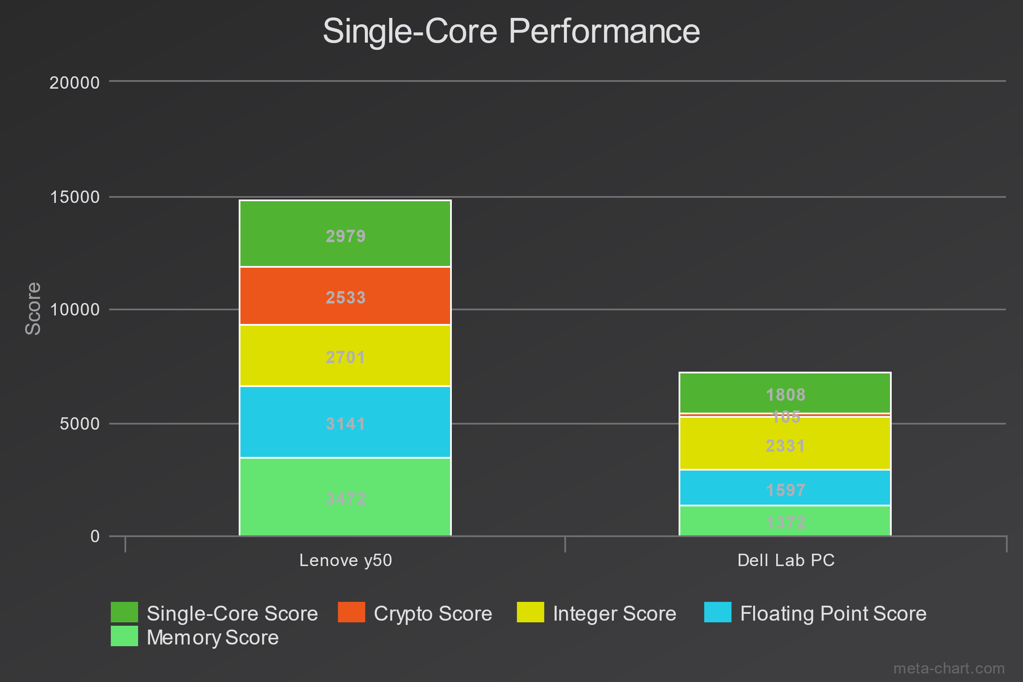

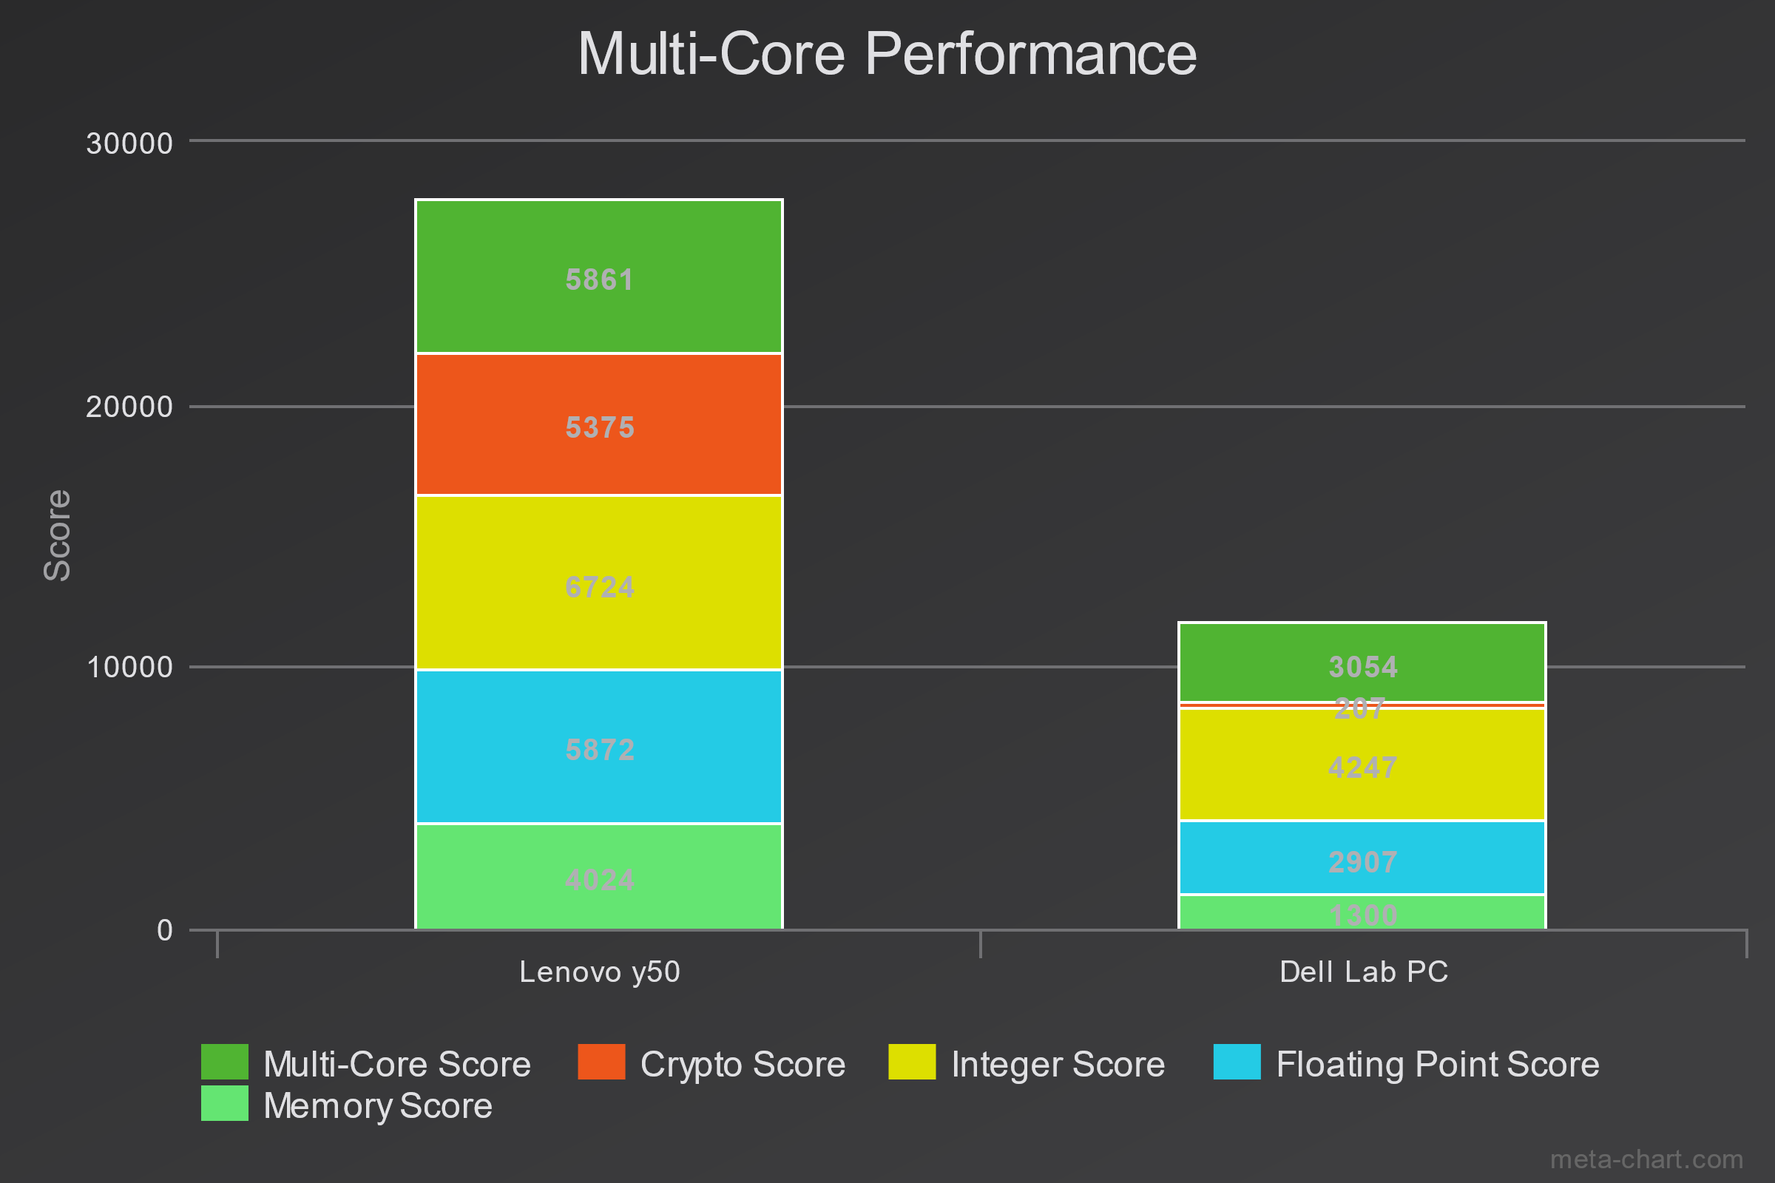

Link to see comparison:

<https://browser.geekbench.com/v4/cpu/compare/7996318?baseline=7996113>

We have observed that the lenevo y50 was better as compared to the Lab PC.

Specially in multicore processing tests.

**Why Geekbenchmark 3 does not simply use the arithmetic mean to average the timings of each micro-benchmark (each constituent code)?**

Because each core’s performance is independent of each other and cannot be taken as a single final evaluated result as the overall results must be in a separate cores result.

